树莓派小车设计

沈杨成1，徐晨康2

（1.宁波工程学院，浙江 宁波 315211；2.宁波工程学院，浙江 宁波 315211）

摘要：小船设计的最终目的应该达到漂浮稳定以及稳定消失角为135°，本报告阐述了我们从选定方程开始一步步进行计算其中使用matlab进行编程计算用来快速计算出答案。其中包括对于重心、浮心、稳定消失角、小船体积、吃水线等的计算，并结合物理以及数学知识计算并推测小船在水中的状态，稳定消失角的大小，回复力矩的大小。之后通过二分法确定最符合题目要求的小船形态及其方程。使用solidwoks对小船进行制图之后进行激光切割，在测试中，小船有着大约10°的偏差漂浮不是很稳定，其稳定消失角也不是计算的135°左右而是达到了160°。这个结果对于我们的计算来说有着较大差距，为此我们进行了分析。总的来说，计算基本符合事实情况，缺少了一些对于其他误差的分析，对于误差所带来的影响需要重新进行更加合理的推测。

树莓派小车

关键词：小船设计；稳定消失角；力矩计算；误差分析；

**Boat design**

SHEN YangCheng1,HUANG YuXin2

(1. Ningbo University of Technology, Ningbo 315211, Zhejiang, China;2. Ningbo University of Technology, Ningbo 315211, Zhejiang, China;)

**Abstract:** The final goal of the boat design should be to achieve the floating stability and stable vanishing angle of 135 °. This report describes that we start from the selected equation to calculate step by step, and use matlab to program calculation to quickly calculate the answer. It includes the calculation of the center of gravity, the center of buoyancy, the stable vanishing angle, the volume of the boat, the waterline, etc., and the calculation of the state of the boat in the water, the size of the stable vanishing angle and the size of the restoring moment by combining the physical and mathematical knowledge. Then, the most suitable boat shape and its equation are determined by dichotomy. In the test, the boat has a deviation of about 10 ° floating is not very stable, and its stable vanishing angle is not about 135 ° but 160 °. This result has a big gap for our calculation, so we analyze it. Generally speaking, the calculation is basically in line with the facts, lacking some analysis of other errors, and the impact of errors needs to be reasoned.

**Keywords:** boat design; angle of vanishing stability; Torque calculation; Error Analysis;

**0 引言**

本文主要研究小船的设计，漂浮稳定性，稳定消失角，力矩的计算。将采用一块50cm*60cm*3mm大小的木板，一个重约106g高50cm的桅杆以及一个直径4cm重约910g的铁块。希望能够打造出一艘漂浮稳定以及稳定消失角在135°左右的小船。本文将结合数学及物理知识来讲述一艘稳定消失角为135°的小船的设计及计算过程，并结合实际情况进行误差分析。主要使用三重积分对小船的体积、吃水线等进行计算，并用物理中的力矩知识对稳定消失角进行计算。

1 相关概念及测试方法

1.1相关概念

吃水线：小船在漂浮时，船身浸没水中体积的高度。

浮心：船浸入水中部分的重心。

稳定消失角：当船舶的横倾角超过一定值时，船舶继续横倾至某一角度，其复原力臂(矩)降为零，此时船舶的稳性消失。

重心：物体各部分所受重力之合力的作用点。

1.2测试方法

将小船放入水中，首先对其静平衡测试观察是否能够漂浮及其漂浮是否稳定（是否与水面平行），之后对其行进性能测试，最后进行稳定消失角测试用手将桅杆压入水中135°，观察其是否能够复原，多次使用不同的角度测量，测出小船实际的稳定消失角。

2数学计算

2.1确定方程

假设小船方程为Axn+Bym=Z，我们通过matlab画图来观察曲线的形式，找出一个合适的形状，并带入进行计算，我们在题目的计算中发现，4次方的方程在计算中比2次的方程计算更为困难，所以决定使用二次方进行计算，之后便用matlab不断的画图，画出一个长宽适合的图进行带入计算。最后我们采用的方程为 $z=3.9x^{2}+20y^{2}$ 高度H采用0.13m。

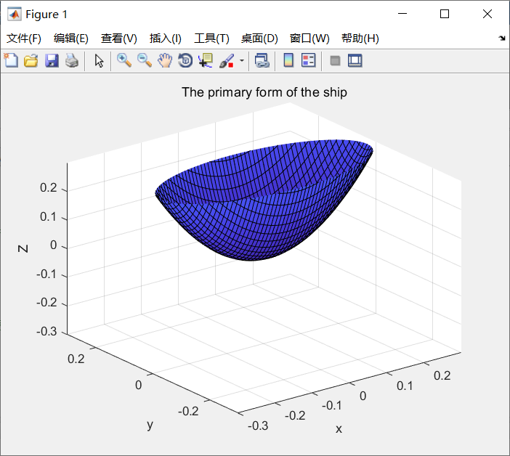

图2-1-1 用matlab观察曲线

2.2计算小船体积

在计算小船体积的时候，我们使用2种积分方式来判断matlab代码是否正确。

从左至右积

$V_{体积}=\int_{-\sqrt{\frac{H}{A}}}^{\sqrt{\frac{H}{A}}}{\int_{-\sqrt{\frac{h-Ax^{2}}{B}}}^{\sqrt{\frac{H-Ax^{2}}{B}}}{\int_{Ax^{2}+By^{2}}^{H}{1}\text{dzdydx}}}$（1）

从下至上积分

$V_{体积}=\int_{-\sqrt{\frac{H}{A}}}^{\sqrt{\frac{H}{A}}}{\int_{-Ax^{2}}^{H}{\int_{-\sqrt{\frac{z-Ax^{2}}{B}}}^{\sqrt{\frac{z-Ax^{2}}{B}}}{1}\text{dydzdx}}}$（2）

以上即为两种不同的积分方式，通过2种积分方式出来的答案是否一致，用来判断matlab代码是否出错。最后带入我们自己A、B的值，得到的体积为0.0030m3 。

2.3计算小船重心

对于重心的计算，我们对于船体的各个部件分别进行计算，最后根据重量进行加权平均，以此求出重心，首先我们的小船是关于x、y轴都对称，所以其重心落在z轴。根据木板材料以及小船所占面积大小得出空船重量为200g左右。

空船重心：

 （3）

$\overline{z}=\frac{M_{xy}}{m}=\frac{\iint_{E}{zρ(x,y,z)}dV}{\iint_{E}{ρ(x,y,z)}dV}=\frac{ρ\iint_{E}{z}dV}{ρ\iint_{E}{1}dV}=\frac{\iint_{E}{z}dV}{\iint_{E}{1}dV}$（4）

$\overline{z}=\frac{\text{0.0002605021869}}{\text{0.0030}}≈0.0867m$（5）

船载重之后的重心：

$\overline{z}=\frac{0.0867*200+0.04*910+0.31*106}{1216}=0.0712m$（6）

所以得出重心位置为（0，0，0.0712）。

2.4吃水线H的确定

吃水线的计算是在小船方程确定之后进行计算，若用matlab迭代出小船吃水线高于船的总高则需将小船的方程重新进行确定，若小船吃水线十分不合理则也需要改变船的方程。计算吃水线的方法是使用迭代的方法。因为水的密度为1g/cm3所以小船排开水的质量等于小船排开水的体积，所以我们采用设船高为H,对其进行三重积分。当船浸没水中的体积等于其排开水的体积时，在此时刻的高度H,即为船的吃水线。

通过小船的质量求出浮力从而得出排水体积。

$F_{浮}=ρ_{水}gV_{排}=m_{总}g$（7）

$V_{体积}=\int_{-\sqrt{\frac{H}{A}}}^{\sqrt{\frac{H}{A}}}{\int_{-\sqrt{\frac{H-Ax^{2}}{B}}}^{\sqrt{\frac{H-Ax^{2}}{B}}}{\int_{Ax^{2}+By^{2}}^{H}{1}\text{dzdydx}}}$（8）

设高度H为未知数，首先H从0开始积分，每一次迭代H增加0.0000001，当积分v-q<0.000001时停止迭代，并输出H,此时高度H,即为吃水线高度，虽有一定误差，但此时误差极小。经过matlab迭代得出吃水线H=0.0826518m。船的高度为0.13m，故该吃水线符合要求。

2.5计算小船正浮浮心

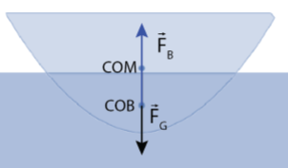

图2-5-1正浮时重心与浮心的位置关系

小船的浮心就是小船浸入水中体积的重心那么由小船方程 $z=3.9x^{2}+20y^{2}$ 可知小船关于x轴与y轴对称，所以重心和浮心在同一条直线上，要计算小船的浮心必须要知道浸入水中体积，通过受力分析可知当小船在水面漂浮时受到一个竖直向下的重力和在同一条直线上的浮力，浮力等于排开水的质量等于小船的质量，小船的质量我们通过第一步可得再通过质量和体积之间的关系可以得出排开水的体积，再通过matlab计算在H为多少时小船的体积等于排开水的体积，得到的H即为小船的吃水线，最后通过上一步计算小船重心的公式即可得到小船的浮心。考虑到实际情况浮心的位置最好在重心之上否则小船容易倾斜。得到实际浮心坐标为（0，0，0.0551）。

浮心： （9）

2.6倾斜一定角度后浮心的位置

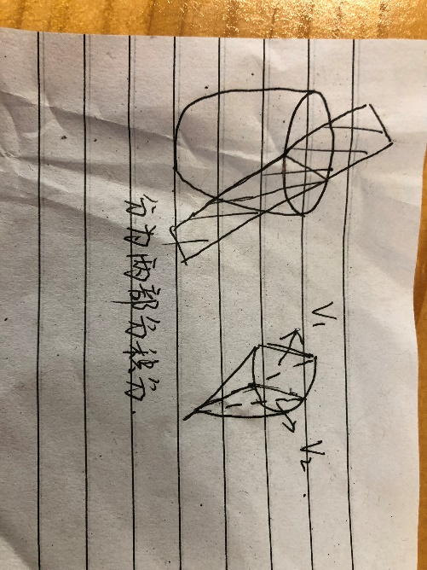

图2-6-1分成2个进行积分

然后就是需要得到我们所设计小船的稳定消失角，为了求得其稳定消失角，我们首先需要知道小船倾斜一定角度后的浮心所在位置，我们知道小船倾斜后在水下一共有四种情况，而小船设计计划书中要求小船的稳定消失角在135°左右（偏差不超过10°）,因此我们只需要考虑一种情况,我们无法直接得出稳定消失角，所以我们需要通过得到小船倾斜一定角度后浮心的位置来确定，共有两种方法，一是直接计算复原力矩，二是通过判断浮心和重心与倾斜后吃水线的相对位置来确定（当浮心和重心的连线与此时的吃水线垂直时当前小船倾斜的角度为稳定消失角），于是我们先计算倾斜一定角度后吃水线的位置，我们设倾斜一定角度时水面的方程为  ，其中  （α°为小船倾斜的角度），于是我们未知数只剩下了b，我们通过和上述相同的方法，通过使用迭代利用matlab求解，当然我们需要知道小船倾斜后吃水线以下部分的体积，由于水下部分难以直接积分得出，所以我们将其分为两部分，先确定第一部分y的积分区间通过求解得到积分下限，接着当x=0时可以得到该平面额的方程，与联解可以得到积分上限，于是第一部分积分方程为

 （10）

同理可得第二部分积分方程为

 （11）

由于有两部分求得总排水的重心（也就是该部分的浮心）需要使用加权平均的方法（以z坐标为例）

$z_{1}=\frac{\iiint_{E_{1}}{z*ρ(x,y,z)}dv}{\iiint_{E_{1}}{ρ(x,y,z)}dv}=\frac{ρ\iiint_{E_{1}}{z}dv}{ρ\iiint_{E_{1}}{1}dv}=\frac{\iiint_{E_{1}}{z}dv}{V_{1}}$（12）

$z_{2}=\frac{\iiint_{E_{2}}{z*ρ(x,y,z)}dv}{\iiint_{E_{2}}{ρ(x,y,z)}dv}=\frac{ρ\iiint_{E_{2}}{z}dv}{ρ\iiint_{E_{2}}{1}dv}=\frac{\iiint_{E_{2}}{z}dv}{V_{2}}$（13）

$z_{总}=\frac{m_{1}z_{1}+m_{2}z_{2}}{m_{1}+m_{2}}=\frac{V_{1}z_{1}+V_{2}z_{2}}{V_{1}+V_{2}}=\frac{\iiint_{E_{1}}{z}\text{dv}+\iiint_{E_{2}}{z}\text{dv}}{V_{1}+V_{2}}$（14）

同理我们可以知道浮心的y坐标，进而确定浮心的位置

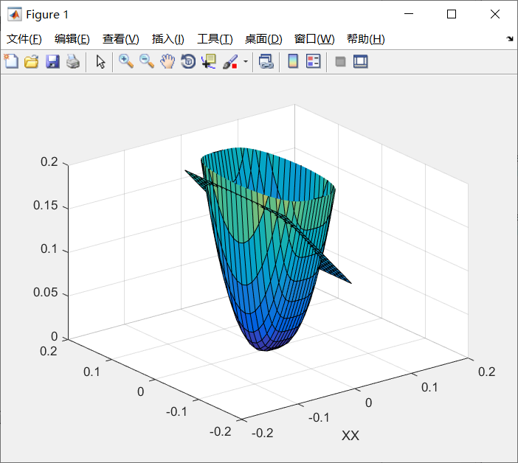

图2-6-2 倾斜135°

2.7确定稳定消失角

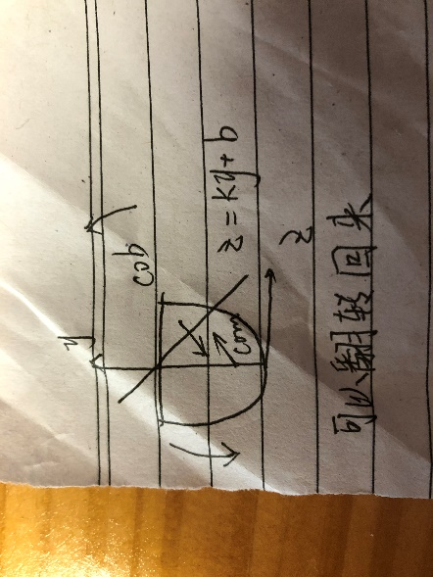 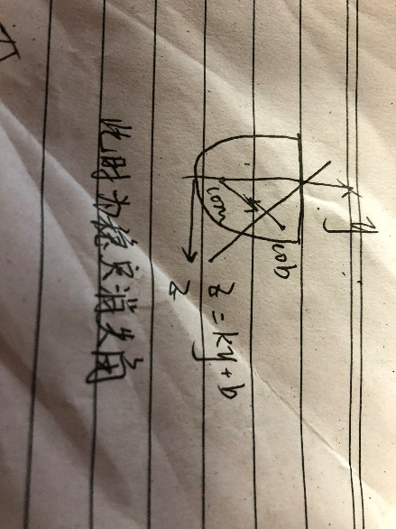

图2-7-1翻转135°时，能否翻回来的情况

根据上面所述内容，我们已经知道倾斜一定角度后浮心和重心以及此时吃水线的位置，倘若小船的稳定消失角为α°时，此时浮心和重心的连线应当与吃水线垂直，也就是浮心与重心的连线和y轴呈（α°-90°）角，倘若不垂直的话，我们可以根据浮心和重心的相对位置来确认稳定消失角的大小，令此时浮心和重心连线与y轴所呈角度为θ°，则根据上述条件，我们可以知道，通过比较tanθ°和tan（α°-90°）的大小，我们可以得到关于θ°和（α°-90°）大小的关系，当前者比后者大的话则此时有一个复原力矩可以让小船转回翻转前的状态，则稳定消失角大于α°，当二者相等时，此时翻转的角度为稳定消失角，当前者比后者小的话，复原力矩给其一个翻转的力，小船将直接翻掉，此时稳定消失角应小于α°。

要确定稳定消失角与此时倾斜角度的相对大小，除了上述方法外，还可以通过计算复原力矩来判断，当然对于复原力矩，若想使方法更加的快捷，我们可以只判断复原力矩的方向，漂浮于水线的船，当重心和浮心不在同一垂线上，重力和浮力形成[力偶](https://baike.baidu.com/item/%E5%8A%9B%E5%81%B6/2712049" \t "https://baike.baidu.com/item/%E5%A4%8D%E5%8E%9F%E5%8A%9B%E7%9F%A9/_blank)，促使船回到初始平衡位置，此时的复原力矩为正值。当重力和浮力形成的力偶，促使船继续横倾，此时的复原力矩为负值。但若想使小船回复时更加的快，我们就要计算特定角度是复原力矩的大小，计算复原力矩的公式若用矢量叉乘的方法我们可以知道这样可以直接计算出力矩的大小和方向，当然也可以利用标量的方法计算，浮力的大小乘两个作用力之间的力臂大小，最后根据产生作用的方向来判断这个复原力矩的正负。

3 制作方法

我们使用软件solidworks以及CAD进行制图，首先我们在matlab中确定了曲线的方程，可以轻易的算出船的长和宽再代入几组数据便可以算出副龙骨的平面，之后在画图软件中进行绘制，首先将各个部分分开进行制图，之后将不同的零件装配起来，最后在保存为CAD的格式，在CAD中打开，将其平铺在50cm*60cm的大小的平面上，完成了制图之后，便是等待切割，切割完毕之后，我们对其进行了组装，在组装过程中，由于手动组装产生的偏差以及小船四周的塑料袋缠绕的不均会导致小船的重心产生偏差。在组装过程中我们为了防止漏水的情况的发生，便绕了很多胶带，最后导致小船下半部分增加了100g，从而使得小船的重心下降，导致稳定消失角增大。关于装饰我们采用了一些贴纸作为装饰，并将其贴在吃水线的位置，一举两得。之后又画了一些图案作为装饰，也有一些纸花放在甲板上作为装饰。

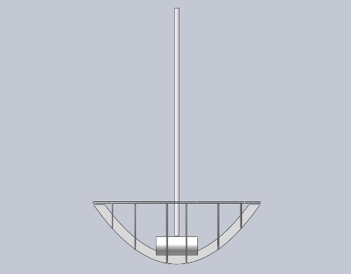

图3-1 小船立体模型

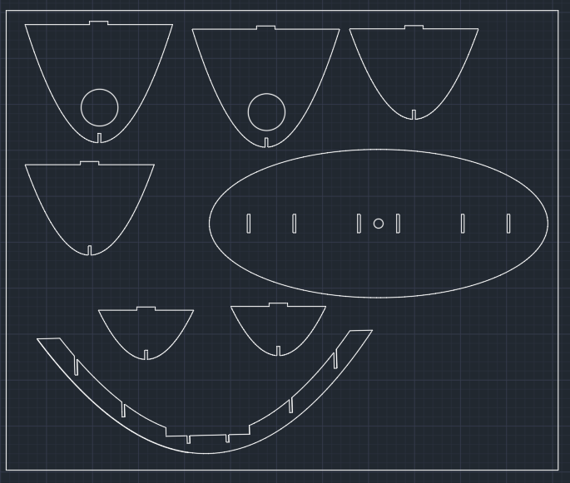

图3-2 在CAD中的模型

4实际测试与改进方案

在实际测试中，小船在微小外力的作用下，漂浮不是很稳定，发生了10°的偏差。从小船的理论计算和实际的操作情况来看，小船的有些理论参数如船体的吃水线等与我们的理论计算十分吻合。在测速中表现良好，小船较平稳的行进，并且速度合理。对于在倾覆135度条件下我们的小船还是出现了一些问题，虽然在倾斜状态下小船的能产生一个与倾覆方向相反的复原力矩。在我们原先的计算条件下，小船的稳定消失角在135度左右，可实际情况是小船的稳定消失角在160度左右，这与我们的计算误差较大。

改进方法

我们的小船在测试中碰到最严重的问题就是不是很水平，当然这其中很重要的一个原因是我们组装的问题，可能装的不是很正，但更严重的一个问题是我们没有考虑到小船水平是浮心和重心的位置关系，我们浮心和重心的位置过于接近，导致只要重心稍微偏了，哪怕一点点都会让船本身产生较大的倾斜，所以改进的方法，我们需要加大浮心和重心之间的距离，一共有两种方式，一是通过减小Ax^2+By^2=z中的A或B来加大每个横截面的面积从而来降低浮心，来增加二者之间的距离，最佳方案是减小B，因为当B减小，小船的宽会增加，从而避免小船成为不倒翁，第二种方法是升高重心，我们可以通过升高整个船的高度或者使用不镂空甲板之类的方法做到，并且重心升高将会让稳定消失角减小，更好的避免了小船成为不倒翁，综上所述，两种方案都是很好的，可以尽可能减小由于组装带来的误差。

5总结：

（1）在这次小船项目中，我们真正的他体会到了何为学科融合，从数学的各类积分到物理的各类知识的实际应用，再到matlab的代码编写，算法的实现，以及到最后的solidword的零件和装配图的设计，以及最最后面的组装装饰，和答辩前绘制的精美的海报。

（2）在小船的制作过程中，不仅从中复习和巩固了数学上的微积分的相关知识，对于物理也是如此，力矩的分析，动态受力过程的分析，空间坐标变换的分析等等。在长宽高的比例上我们的比例可优化性较大，因为我们考虑的限制因素过少，不仅仅是船的重心、稳心等实在性因素，船体外界的阻力等微小抗干扰因素也得考虑在内。

6 参考文献

1. QEA_M1_Boat_Report_and_Letter_to_Editor

7附录

小船重心

syms x y z b;

A=3.9;

B=20;

H=0.0826518;

fun=@(x,z) 2*sqrt((z-A*x.^2)/B);

q=integral2(fun,-sqrt(H/A),sqrt(H/A),@(x)A.*x.^2,H);

fun1=@(x,z) 2.*z.*sqrt((z-A*x.^2)/B);

i=integral2(fun1,-sqrt(H/A),sqrt(H/A),@(x)A.*x.^2,H)

吃水线H

H=0.080658300000096;

format long;

A=3.9;

B=20;

while(H<0.15)

H=H+0.0000001

fun=@(x,y) H-A.*x.^2-B.*y.^2;

q=integral2(fun,-sqrt(H/A),sqrt(H/A),@(x)-sqrt((H-A.*x.^2)/B),@(x)sqrt((H-A.*x.^2)/B))

v=0.001216;

if v-q<=0.000001

break

end

end

H

截距b

b=0.095;

format long;

A=3.9;

B=20;

H=0.13;

tan=-1;

while(b<5)

b=b+0.0000001

fun=@(y,z) 2.*sqrt((H-B.*y.^2)./A);

q=integral2(fun,b-H,(tan+sqrt((tan.^2)+4.*B.*b))/(2.*B),@(y)tan.*y+b,H);

fun1=@(z,y) 2*sqrt((H-B.*y.^2)/A);

w=integral2(fun1,tan.*(tan+sqrt((tan.^2)+4.*B.*b))/(2.*B)+b,H,(tan+sqrt((tan.^2)+4*B.*b))/(2*B),@(z)sqrt(z./B));

s=q+w

%q=q*10;

v=0.001285;

%v=v*10;

if s-v<=0.0000001

break

end

end

b

AVS

b=0.095450;

format long;

A=3.9;

B=20;

H=0.13;

tan=-1;

funy=@(y,z) 2.*y.*sqrt((H-B.*y.^2)./A);

qy=integral2(funy,b-H,(tan+sqrt(tan.^2+4*B.*b))/(2*B),@(y)tan*y+b,H);

funz=@(y,z) 2.*z.*sqrt((H-B.*y.^2)./A);

qz=integral2(funz,b-H,(tan+sqrt(tan.^2+4*B.*b))/(2*B),@(y)tan*y+b,H);

fun1y=@(z,y) 2*y.*sqrt((H-B.*y.^2)/A);

wy=integral2(fun1y,tan*(tan+sqrt(tan.^2+4*B.*b))/(2*B)+b,H,(tan+sqrt(tan.^2+4*B.*b))/(2*B),@(z)sqrt(z./B));

fun1z=@(z,y) 2*z.*sqrt((H-B.*y.^2)/A);

wz=integral2(fun1z,tan*(tan+sqrt(tan.^2+4*B.*b))/(2*B)+b,H,(tan+sqrt(tan.^2+4*B.*b))/(2*B),@(z)sqrt(z./B));

sy=qy+wy

sz=qz+wz

%vpa(sy)

%vpa(sz)

%yy=sy/0.001266

zz=sz/0.001266

0 Introduction

This paper mainly studies the design of the boat, the floating stability, the stable vanishing angle and the calculation of the moment. We hope to build a small boat with a stable floating and disappearing angle of 135 °. In this paper, the design and calculation process of a small boat with a stable vanishing angle of 135 ° will be described with mathematical and physical knowledge, and the error analysis will be carried out in combination with the actual situation. It mainly uses triple integral to calculate the volume and waterline of the boat, and uses the moment knowledge in physics to calculate the stable vanishing angle.

1 Related concepts and test methods

* 1. Related concepts

Waterline: the height of a boat's body submerged in water when it is floating.

Center of buoyancy: the center of gravity of the submerged part of a ship.

Stable vanishing angle: when the ship's roll angle exceeds a certain value, the ship continues to roll to a certain angle, and its restoring arm (moment) is reduced to zero, at this time, the ship's stability disappears.

Center of gravity: the point of action of the resultant force of gravity on all parts of an object.

* 1. test methods

Put the boat into the water, first observe whether it can float and whether it can float stably through static balance test, then test its traveling performance, finally, press the mast into the water 135 ° by hand for stability test, observe whether it can recover, and measure the actual stable disappearance angle of the boat.

2 Mathematical calculation

2.1 decide equation



Figure 2-1 Draw figure in matlab

We use matlab to draw a graph to observe the form of the curve, find a suitable shape, and bring it into the calculation. We find that the equation of the fourth power is more difficult than the equation of the second power in the calculation of the topic, so we decide to use the second power for calculation, and then use matlab to draw a graph of suitable length and width to carry it into the calculation. At last, we use the equation $z=3.9x^{2}+20y^{2}$ height h 0.13m.

2.2 Calculate boat volume

When calculating the volume of the boat, we use two integration methods to determine whether the matlab code is correct.

Integral from left to right

$V_{体积}=\int_{-\sqrt{\frac{H}{A}}}^{\sqrt{\frac{H}{A}}}{\int_{-\sqrt{\frac{H-Ax^{2}}{B}}}^{\sqrt{\frac{H-Ax^{2}}{B}}}{\int_{Ax^{2}+By^{2}}^{H}{1}\text{dzdydx}}}$（1）

Integral from bottom to top

$V_{体积}=\int_{-\sqrt{\frac{H}{A}}}^{\sqrt{\frac{H}{A}}}{\int_{-Ax^{2}}^{H}{\int_{-\sqrt{\frac{z-Ax^{2}}{B}}}^{\sqrt{\frac{z-Ax^{2}}{B}}}{1}\text{dydzdx}}}$（2）

The above are two different integration methods. The answer from the two integration methods is the same, which is used to judge whether the matlab code is wrong. Finally, we bring in the values of our own A and B, and the volume is 0.0030m3.

2.3 Calculate the center of gravity of the boat

For the calculation of the center of gravity, we calculate each part of the hull separately, and finally calculate the center of gravity by weighted average according to the weight. First, our boat is symmetrical about the X and Y axes, so its center of gravity falls on the Z axis. According to the wood materials and the size of the boat area, the weight of the empty boat is about 200g.

Center of gravity of empty boat:

 （3）

$\overline{z}=\frac{M_{xy}}{m}=\frac{\iint_{E}{zρ(x,y,z)}dV}{\iint_{E}{ρ(x,y,z)}dV}=\frac{ρ\iint_{E}{z}dV}{ρ\iint_{E}{1}dV}=\frac{\iint_{E}{z}dV}{\iint_{E}{1}dV}$（4） $\overline{z}=\frac{\text{0.0002605021869}}{\text{0.0030}}≈0.0867m$（5）

Center of gravity after loading:

$\overline{z}=\frac{0.0867*200+0.04*910+0.31*106}{1216}=0.0712m$（6）

So the center of gravity is (0, 0, 0.0712).

2.4 Determination of waterline H

The calculation of the waterline is carried out after the determination of the boat equation. If the waterline of the boat is higher than the total height of the boat by MATLAB iteration, the equation of the boat needs to be determined again. If the waterline of the boat is very unreasonable, the equation of the boat also needs to be changed. The way to calculate the waterline is to use the iterative method. Because the density of the water is 1g / cm3, the mass of the water discharged by the boat is equal to the volume of the water discharged by the boat, so we set the height of the boat as h to triple integrate it. When the volume of submerged water is equal to the volume of discharged water, the height h at this time is the waterline of the boat.

$V_{体积}=\int_{-\sqrt{\frac{H}{A}}}^{\sqrt{\frac{H}{A}}}{\int_{-\sqrt{\frac{H-Ax^{2}}{B}}}^{\sqrt{\frac{H-Ax^{2}}{B}}}{\int_{Ax^{2}+By^{2}}^{H}{1}\text{dzdydx}}}$（7）

Let the height H be an unknown number. First, H starts to integrate from 0, and each iteration h increases by 0.0000001. When the integral v-q is less than 0.000001, the iteration is stopped and H is output. At this time, the height h is the height of the waterline. Although there is a certain error, the error is very small at this time. After matlab iteration, the waterline H = 0.0826518m. The boat's height is 0.13M, so the waterline meets the requirements.

2.5 calculate the center of buoyancy of the boat



Figure 2-5 position relationship between center of gravity and center of buoyancy during floating

The center of buoyancy of a boat is the center of gravity of the volume of the boat submerged in the water. From the boat equation z = 3.9x2 + 20Y2, we can know that the boat is symmetrical about the x-axis and the y-axis, so the center of gravity and the center of buoyancy are in the same straight line. To calculate the center of buoyancy of a boat, we must know the volume of the boat submerged in the water. Through the force analysis, we can know that when the boat floats on the water, it is subject to a vertical downward gravity and the buoyancy in the same straight line The buoyancy is equal to the mass of the discharged water, which is equal to the mass of the boat. The mass of the boat can be obtained through the first step, and then the volume of the discharged water can be obtained through the relationship between the mass and the volume. Then the volume of the boat is equal to the volume of the discharged water when h is calculated through MATLAB, and the H obtained is the waterline of the boat. Finally, the formula of the barycenter of the boat can be obtained through the previous step The boat's buoyancy center. Considering the actual situation, the position of the center of buoyancy is better above the center of gravity or the boat is easy to tilt. The actual floating center coordinates are (0, 0, 0.0551).

2.6 position of floating center after inclining to a certain angle



Figure 2-6-1 Integral in two parts

Then we need to get the stable vanishing angle of the designed boat. In order to get the stable vanishing angle, we first need to know the position of the floating center after the boat tilts at a certain angle. We know that there are four situations when the boat tilts underwater, and the stable vanishing angle of the boat is required to be about 135 ° in the boat design plan (the deviation is not more than 10 °), so we only need to know the position of the floating center after the boat tilts at a certain angle To consider a case, we can't get the stable vanishing angle directly, so we need to determine the position of the floating center after the boat tilts at a certain angle. There are two methods, one is to directly calculate the restoring moment, the other is to determine the relative position of the center of buoyancy and the center of gravity with the inclined waterline (when the line between the center of buoyancy and the center of gravity is perpendicular to the waterline at this time, the current angle of the boat's inclination is the stable vanishing angle), so we first calculate the position of the waterline after the inclined angle. We set the equation of water surface at a certain angle as $z=\text{ky}+b$，and $k=\text{tan}α°$ (α ° is the angle of inclination of the boat)，So we only have b as the unknown number. We use the same method as above and use matlab to solve it b y iteration. Of course, we need to know the volume of the part below the waterline after the boat tilts. Because the underwater part is difficult to be directly integrated, we divide it into two parts. First, we determine the integration interval of the first part y and get the lower integration limit by solving $H=\text{ky}+b$, then When x = 0, we can get the equation $z=\text{B}{\text{y}}^{2}$ of the plane, and we can get the upper limit of the integral by combining with $z=\text{ky}+b$, so the first part of the integral equation is

$V_{1}=\int_{\frac{H\text{-b}}{k}}^{\frac{k+\sqrt{（-k）^{2}+4Bb}}{2B}}{\int_{\text{ky}+b}^{H}{\int_{-\sqrt{\frac{H-By^{2}}{A}}}^{\sqrt{\frac{H-By^{2}}{A}}}{1}\text{dxdzdy}}}$（8）

Similarly, the second part of the integral equation is $V_{2}\int_{\frac{k+\sqrt{（-k）^{2}+4Bb}}{2B}}^{\sqrt{\frac{H}{B}}}{\int_{k(\frac{k+\sqrt{（-k）^{2}+4Bb}}{2B})+b}^{H}{\int_{-\sqrt{\frac{H-By^{2}}{A}}}^{\sqrt{\frac{H-By^{2}}{A}}}{1}\text{dxdzdy}}}$（9）

Because there are two parts to get the center of gravity of the total drainage (that is, the floating center of this part), the weighted average method is needed (take Z coordinate as an example).

$z_{1}=\frac{\iiint_{E_{1}}{z*ρ(x,y,z)}dv}{\iiint_{E_{1}}{ρ(x,y,z)}dv}=\frac{ρ\iiint_{E_{1}}{z}dv}{ρ\iiint_{E_{1}}{1}dv}=\frac{\iiint_{E_{1}}{z}dv}{V_{1}}$（10）

$z_{2}=\frac{\iiint_{E_{2}}{z*ρ(x,y,z)}dv}{\iiint_{E_{2}}{ρ(x,y,z)}dv}=\frac{ρ\iiint_{E_{2}}{z}dv}{ρ\iiint_{E_{2}}{1}dv}=\frac{\iiint_{E_{2}}{z}dv}{V_{2}}$（11）

$z_{总}=\frac{m_{1}z_{1}+m_{2}z_{2}}{m_{1}+m_{2}}=\frac{V_{1}z_{1}+V_{2}z_{2}}{V_{1}+V_{2}}=\frac{\iiint_{E_{1}}{z}\text{dv}+\iiint_{E_{2}}{z}\text{dv}}{V_{1}+V_{2}}$（12）

In the same way, we can know the Y coordinate of the floating center, and then determine the position of the floating center.



Figure2-6-2 Tilting 135 degrees

2.7 Determine AVS

 

Figure2-7-1and2-7-2 Determine AVS

According to the above, we have known the center of buoyancy and the center of gravity and the position of the waterline at this time when the angle of steady disappearance of the boat is α °, At this time, the line between the center of buoyancy and the center of gravity should be perpendicular to the waterline, that is, the line between the center of buoyancy and the center of gravity and the y-axis should have an angle of (α ° - 90 °). If not, we can confirm the size of the stable disappearance angle according to the relative position of the center of buoyancy and the center of gravity, so that the angle between the line of the center of buoyancy and the center of gravity and the y-axis is θ °, then according to the above conditions, as we all know,

$\text{ tan}θ°=\frac{△z}{△y}=\frac{z_{总}\text{-}{\text{z}}_{重}}{y_{总}}$（13）

By comparing the magnitude of tan θ ° and tan (α ° - 90 °), we can get the relationship between the magnitude of θ ° and (α ° - 90 °). If the current one is larger than the latter, then there is a restoring moment that can make the boat turn back to the state before turning, then the stable disappearing angle is larger than α °. If the two are equal, then the turning angle is the stable disappearing angle, and if the current one is smaller than the latter, the restoring force The moment gives it a turning force, and the boat will directly turn over. At this time, the stable vanishing angle should be less than α °. To determine the relative size of the stable vanishing angle and the inclination angle at this time, in addition to the above methods, we can also judge by calculating the restoring moment. Of course, for the restoring moment, if we want to make the method more efficient, we can only judge the direction of the restoring moment. For ships floating on the waterline, when the center of gravity and the center of buoyancy are not on the same vertical line, gravity and buoyancy form a couple of forces, so that the ship can return to the original position At the initial balance position, the restoring moment is positive. When the couple of gravity and buoyancy forces causes the ship to continue heeling, the restoring moment is negative. But if we want to make the boat recover faster, we need to calculate the restoring moment at a specific angle, $\overset{→}{M_{r}}=\overset{→}{F_{浮}}×\overset{→}{r}$. In this way, the magnitude and direction of the moment can be calculated directly. Of course, the scalar method can also be used to calculate. The magnitude of the buoyancy is multiplied by the magnitude of the arm between the two forces. Finally, the positive and negative of the restoring moment can be determined according to the direction of the action.

3 Production plan

We use the software solid works and CAD to draw the boat. First, we determine the equation of the curve in MATLAB. We can easily calculate the length and width of the boat, and then substitute several groups of data to calculate the plane of the sub keel. Then we draw it in the drawing software. First, we draw each part separately, then assemble different parts, and finally save it as CAD Format: open it in CAD and lay it on a plane of 50cm * 60cm. After drawing, we wait for cutting. After cutting, we assemble it. In the assembly process, the deviation caused by manual assembly and the uneven wrapping of plastic bags around the boat will lead to the deviation of the center of gravity of the boat. In order to prevent water leakage, we wound a lot of tape during the assembly process, resulting in an increase of 100g in the lower part of the boat, thus lowering the center of gravity of the boat and increasing the stable vanishing angle. As for decoration, we use some stickers as decoration and stick them on the position of the waterline to kill two birds with one stone. After that, I drew some patterns for decoration, and some paper flowers were put on the deck for decoration.



Figure3-1 model in solid works



Figure3-2 model in CAD

4 test and Improvement plan

In the test, under the action of small external force, the floating of the boat is not very stable, and a deviation of 10 ° occurs. From the theoretical calculation and practical operation of the boat, some theoretical parameters of the boat, such as the waterline of the hull, are very consistent with our theoretical calculation. In the speed measurement, the performance is good, the boat is more stable, and the speed is reasonable. There are still some problems for our boat under the condition of overturning 135 degrees, although the boat can produce a restoring moment opposite to the overturning direction under the condition of inclining. In our original calculation condition, the stable vanishing angle of the boat is about 135 degrees, but the actual situation is that the stable vanishing angle of the boat is about 160 degrees, which is quite different from our calculation.

Improvement plan

The most serious problem encountered by our boat in the test is that it is not very horizontal. Of course, one of the most important reasons is that we have assembled the boat, which may not be very correct. But the more serious problem is that we did not consider that the boat's level is the position relationship between the center of buoyancy and the center of gravity. The position of our center of buoyancy and the center of gravity is too close, so as long as the center of gravity slightly deviates, which For fear that a little bit will make the ship incline greatly, so we need to increase the distance between the center of buoyancy and the center of gravity. There are two ways to improve the method. One is to increase the area of each cross section by reducing a or B in ax ^ 2 + by ^ 2 = Z, so as to reduce the center of buoyancy and increase the distance between them. The best way is to reduce B, because when b decreases, the width of the boat will increase In order to avoid the boat from becoming a tumbler, the second method is to raise the center of gravity. We can do this by raising the height of the whole boat or by using a non hollow deck, and the increase of the center of gravity will reduce the stable vanishing angle, so as to better avoid the boat from becoming a tumbler. In summary, both schemes are very good, which can reduce the errors caused by assembly as much as possible Poor.

5 Summary:

（1）In this boat project, we really realized what is the integration of disciplines, from the various kinds of mathematical integration to the practical application of various kinds of physical knowledge, to the code writing of MATLAB, the realization of algorithm, and to the design of the parts and assembly drawings of solidword, as well as the assembly decoration at the back, and the exquisite posters drawn before the defense.

（2）In the process of making the boat, not only review and consolidate the relevant knowledge of calculus in mathematics, but also for physics, analysis of moment, analysis of dynamic force process, analysis of spatial coordinate transformation, etc. In the aspect of the ratio of length, width and height, our ratio can be optimized greatly, because we consider too few limiting factors, not only the real factors such as the center of gravity and stability of the ship, but also the small anti-interference factors such as the resistance outside the ship.

6 references

1. QEA_M1_Boat_Report_and_Letter_to_Editor

7appendix

Boat center of gravity

syms x y z b;

A=3.9;

B=20;

H=0.0826518;

fun=@(x,z) 2*sqrt((z-A*x.^2)/B);

q=integral2(fun,-sqrt(H/A),sqrt(H/A),@(x)A.*x.^2,H);

fun1=@(x,z) 2.*z.*sqrt((z-A*x.^2)/B);

i=integral2(fun1,-sqrt(H/A),sqrt(H/A),@(x)A.*x.^2,H)

waterline

H=0.080658300000096;

format long;

A=3.9;

B=20;

while(H<0.15)

H=H+0.0000001

fun=@(x,y) H-A.*x.^2-B.*y.^2;

q=integral2(fun,-sqrt(H/A),sqrt(H/A),@(x)-sqrt((H-A.*x.^2)/B),@(x)sqrt((H-A.*x.^2)/B))

v=0.001216;

if v-q<=0.000001

break

end

end

H

Intercept b

b=0.095;

format long;

A=3.9;

B=20;

H=0.13;

tan=-1;

while(b<5)

b=b+0.0000001

fun=@(y,z) 2.*sqrt((H-B.*y.^2)./A);

q=integral2(fun,b-H,(tan+sqrt((tan.^2)+4.*B.*b))/(2.*B),@(y)tan.*y+b,H);

fun1=@(z,y) 2*sqrt((H-B.*y.^2)/A);

w=integral2(fun1,tan.*(tan+sqrt((tan.^2)+4.*B.*b))/(2.*B)+b,H,(tan+sqrt((tan.^2)+4*B.*b))/(2*B),@(z)sqrt(z./B));

s=q+w

%q=q*10;

v=0.001285;

%v=v*10;

if s-v<=0.0000001

break

end

end

b

AVS

b=0.095450;

format long;

A=3.9;

B=20;

H=0.13;

tan=-1;

funy=@(y,z) 2.*y.*sqrt((H-B.*y.^2)./A);

qy=integral2(funy,b-H,(tan+sqrt(tan.^2+4*B.*b))/(2*B),@(y)tan*y+b,H);

funz=@(y,z) 2.*z.*sqrt((H-B.*y.^2)./A);

qz=integral2(funz,b-H,(tan+sqrt(tan.^2+4*B.*b))/(2*B),@(y)tan*y+b,H);

fun1y=@(z,y) 2*y.*sqrt((H-B.*y.^2)/A);

wy=integral2(fun1y,tan*(tan+sqrt(tan.^2+4*B.*b))/(2*B)+b,H,(tan+sqrt(tan.^2+4*B.*b))/(2*B),@(z)sqrt(z./B));

fun1z=@(z,y) 2*z.*sqrt((H-B.*y.^2)/A);

wz=integral2(fun1z,tan*(tan+sqrt(tan.^2+4*B.*b))/(2*B)+b,H,(tan+sqrt(tan.^2+4*B.*b))/(2*B),@(z)sqrt(z./B));

sy=qy+wy

sz=qz+wz

%vpa(sy)

%vpa(sz)

%yy=sy/0.001266

zz=sz/0.001266